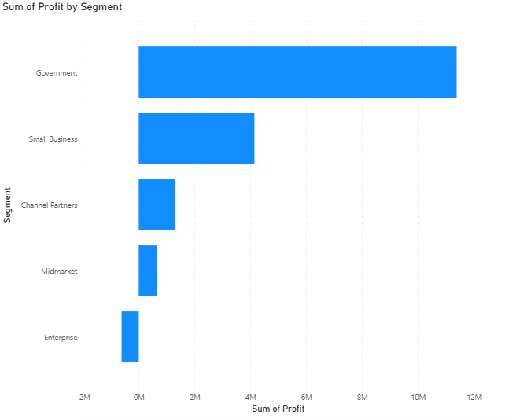

**QUESTION :**

What is the profit generated by different market segments?

**CHART TYPE :**

Stacked Bar Chart

**Y Axis** - Segment**, X Axis** - Sum of Profit

**INSIGHTS :**

1)The **Government** segment drives the highest profit, with a total of **₹1,13,88,173**.

2)**Small Business** is the second-highest profit segment, earning **₹41,43,168**.

3)**Channel Partners** generate less profit, totaling **₹13,16,803**.

4)**Midmarket** is the segment with the second-lowest profit, at **₹6,60,103**.

5)**Enterprise** does not generate profit; instead, it records a **loss of ₹6,14,545**.